The Issue

The latest update of Bforartists brings some new editor types; but with that, most older Bforartists *.blend files will possibly cause a crash in the latest Bforartists release, meaning some older files will need updating to be compatible.

How to Update your Files

1. Prepare the old file

Open an older version of Bforartists, open up the file you would like to update. Rename the scene to a sutable name. This is optional.
Tip
Renaming your scene to not be confused will help keep the migration quick and easy.

2. Append the Scene

In the new version of Bforartists, make a new scene. Then append the Scene data from the old file, and switch to the new scene.

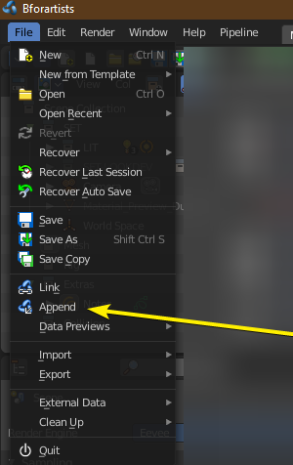
Go to File>Append

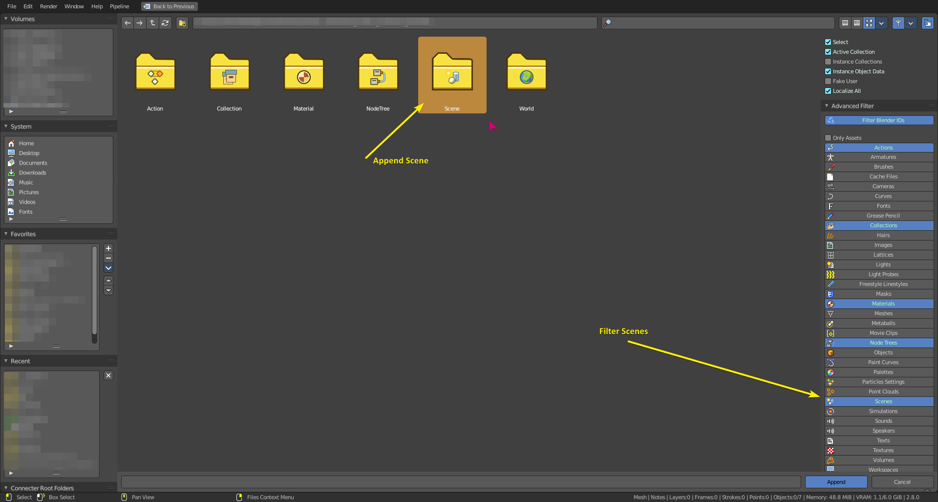
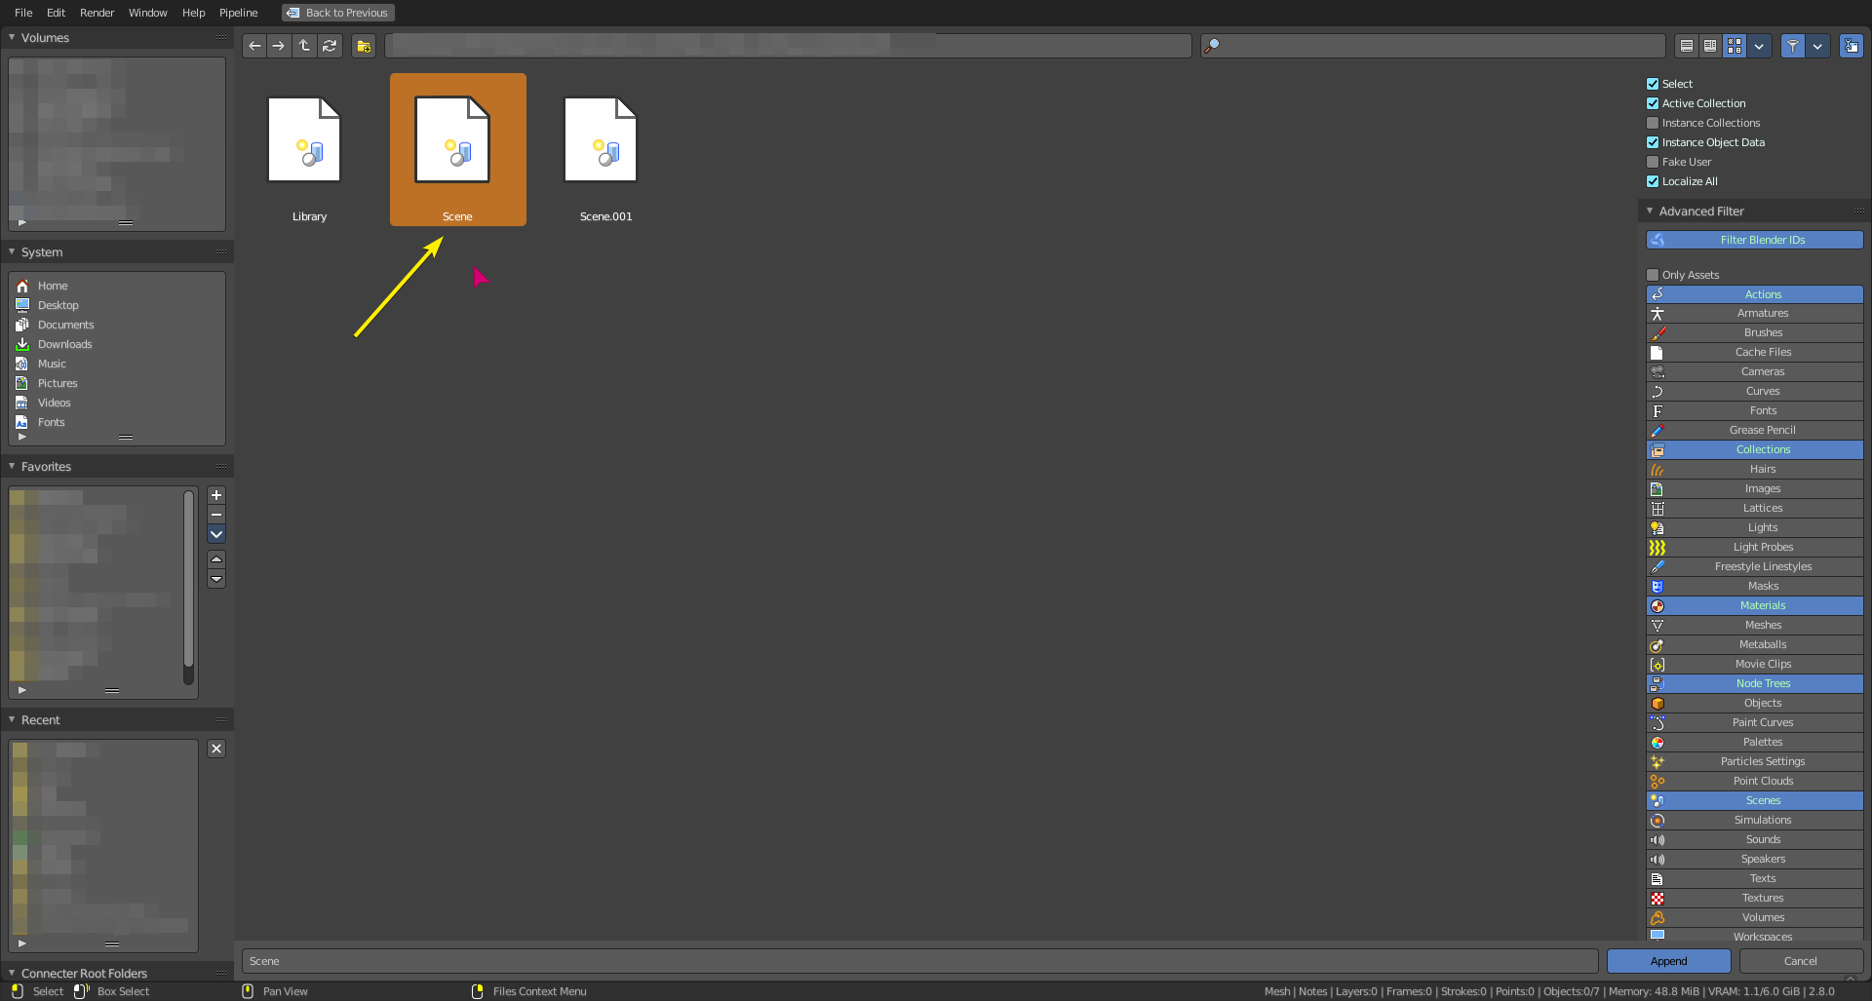
Filter and enter the Scene Data folder of your blend file.
Append the relevant scene data. This is a top level data container of *.blend files - which will append all objects, scenes, textures and more to another empty blend file.

3. Manage the new Scene Data
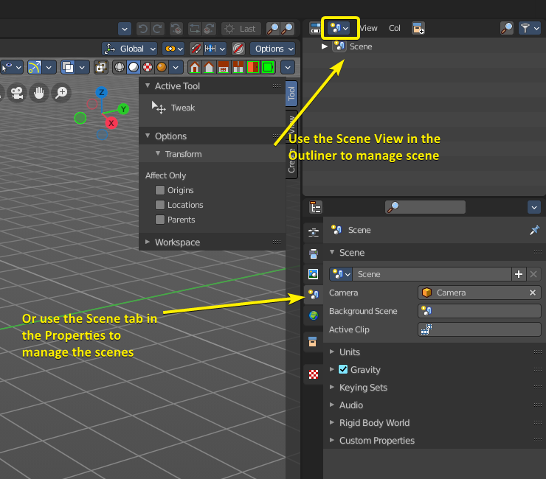
With the new Scene data appended, you can then use the Scene View of the outliner, the Scene dropdown in the Misc group of the toolbar, or the Scene tab of the Properties editor to manage your scene. You can switch to it, remove others, and/or copy them.
4. Save As a new file
Once all your new scene data is appended, you can save as a new file.

